A SUMMER INTERNSHIP REPORT on

WEB DEVELOPMENT

Submitted in partial fulfillment of the requirements of the degree

BACHELOR OF TECHNOLOGY
IN

COMPUTER SCIENCE AND ENGINEERING

Submitted By
VALAVALA RAJESWARI

(O191021)

Under the supervision of
Next24Tech Technologies



DEPARTMENT OF COMPUTER SCIENCE AND ENGINEERING,

RAJIV GANDHI UNIVERSITY OF KNOWLEDGE TECHNOLOGIES,
ONGOLE CAMPUS,2024.

DEPARTMENT OF COMPUTER SCEIENCE AND ENGINEERING,
RAJIV GANDHI UNIVERSITY OF KNOWLEDGE TECHNOLOGIES,
ONGOLE CAMPUS,2024.



BONAFIDE CERTIFICATE

This is to certify that the internship report entitled “WEB DEVLOPMENT” Submitted by RAJESWARI VALAVALA partial fulfilment of the requirement for the award of Bachelor of Technology in Computer Science and Engineering is a record of bonafide internship carried out under my supervision during the academic year 2024.
I am extremely thankful and pay my gratitude to Mr.M.Krishna, (C) Assistance Professor, CSE, for
his valuable guidance and support on the completion of this project.
The report hasn’t been submitted previously in part or full to this or any other university or institution for the award of any degree.

Mr.M. Krishna M.Tech, Mr.N. Mallikarjuna M.E
Assistant Professor, Head of Department(I/C),
CSE Department, Department of CSE,
RGUKT, ONGOLE. RGUKT, ONGOLE.

APPROVAL SHEET

This report entitled “WEB DEVELOPMENT” submitted by Rajeswari Valavala (O191021) is Mr. M.Krishna approved for the degree of Bachelor of Technology in COMPUTER SCIENCE AND ENGINEERING.

Examiner(s)

_________________________________

Supervisor

Chairman

__________________________

Date:_________________

Place:________________

DECLARATION

I declare that this written submission represents my ideas in my own words where other ideas or words have been included, I have adequately cited and referenced the original sources. I also declare that I have adhered to all principles of academic honestly and integrity and have not misrepresented or fabricated or falsified any idea /data/fact/source in my submission.
I understand that any violation of the above will be cause for disciplinary action by the institute and can also evoke penal action from the sources which have thus not been properly cited or from whom proper permission has not been taken when needed.

Signature _________________

Name of the Student __________________

ID NO _____________________

Date:________________

ACKNOWLEDGEMENT

Firstly I would like to thank the team of Next24Tech Technologies for giving me this opportunity to do an virtual internship within the organization.
I am highly indebted to Mr.M.Krishna for his guidance and constant supervision as well as for providing necessary information regarding the internship and also for their kind cooperation, encouragement and their support in completing the internship.
I would like to express my special gratitude and thanks to our COMPUTER SCIENCE AND ENGINEERING branch H.O.D Mr.N.MALLIKARJUNA and Director of Ongole-RGUKT Dr.P.BASKAR PATEL sir for giving me such attention and time.

I have taken efforts in this internship. However, it could not have been possible without the kind support and help of many individuals and RGUKT. I would like to extend my sincere thanks to all of them.

With Sincere Regards,
Rajeswari Valavala.

DATE:________________

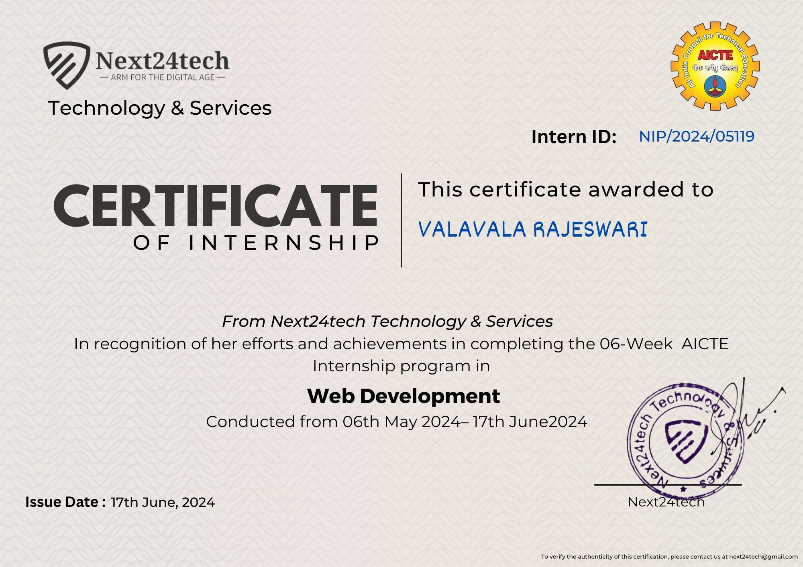
INTERNSHIP COMPLETION CERTIFICATE

ABSTRACT

Web development focuses on creating the visual and interactive aspects of a website that users see and interact with. It involves using technologies like HTML, CSS, and JavaScript to build and design web pages. HTML structures the content, CSS styles it, and JavaScript adds interactive features.
HTML (HyperText Markup Language) is the backbone of web content. It structures web pages with elements like headings, paragraphs, images, and links. CSS (Cascading Style Sheets) is used to style and layout web pages, controlling the colors, fonts, spacing, and overall layout of the content. JavaScript adds interactivity and dynamic features to web pages, enabling functionalities like form validation, interactive maps, and content updates without reloading the page. Front end developers work to ensure that websites are user-friendly, responsive and visually appealing. They also focus on optimizing web performance and ensuring compatibility across various web browsers.

TABLE OF CONTENTS
Description Page No

Title i

Bonafide Certificate ii

Approval Sheet iii

Declaration iv

Acknowledgement v

Internship Certificate vi

Abstract vii

1 INTRODUCTION
  - Introduction 1
  - Internship Activities 1
2 REQUIREMENT ANALYSIS
2.1 Requirement Specification 2
2.1.1 Hardware Requirements 2
2.1.2 Software Requirements 2
2.2 Technologies Used 2-4
3 SYSTEM DESIGN
3.1 Class Diagram 5
3.2 Object Diagram 6
3.3 Component Diagram 7
4 SOFTWARE ENVIRONMENT 8
5 IMPLEMENTATION
5.1 Sample Code 9-36
5.2 Sample Screenshots 37-43
6 CONCLUSION 44
7 REFERENCES 45

CHAPTER 1
1

INTRODUCTION

Introduction
Web development that focuses on creating the user interface and user experience of a website or web application. It involves the use of HTML, CSS, and JavaScript to build the visual and interactive elements that users interact with directly. HTML (HyperText Markup Language) serves as the backbone of any web page, providing the structure and content by defining elements such as headings, paragraphs, links, and images. CSS (Cascading Style Sheets) is used for styling and layout, controlling the appearance of HTML elements, including colors, fonts, and spacing, and ensuring web pages are visually appealing and responsive across different devices. JavaScript is a scripting language that adds interactivity and dynamic behavior to web pages, enabling functionalities like form validation, animations, and user-triggered events. Together, these technologies form the foundation of front-end development, enabling developers to create engaging and efficient user experiences.

Overview of Internship Activities

My Portfolio

    - Designed a portfolio website, which will describes all information about me.
    - I divide the webpage into different sections i.e Home, About, Education,Projects and Contact.

E-commerce Website

    - Designed a E-commerce webiste which is used to shopping in Online.
    - It have features a product catalog where a variety of items are displayed with images, detailed descriptions, and prices.

E-Learning website

    - Designed a E-Learning webiste which is used to learn courses and read books in Online.
    - It offers a variety of courses and books, providing users with access to educational content and resources for learning at their own pace.

CHAPTER – 2 REQUIREMENT ANALYSIS

In order to run an application we need to have some basic configuration related to hardware and software. The following were the listed requirements to run the Dynamic dashboard and Report card smoothly.

Requirement Specification

Hardware Requirements

      - Processor : Intel i3 or above

      - Memory : 4 GB RAM or above

Software Requirements

      - Operating System : Windows / Linux / Mac /Android

      - Browser : Chrome /Safari/Mozilla firefox

Technologies Used

HTML

It is a markup language for formatting and displaying web documents and web pages. It gives basic structure to the web page without any styling. HTML elements tell the browser how to display the content. It can be assisted by technologies such as Cascading Style Sheets and scripting languages such asJavaScript for styling and functionality.

- HTML stands for Hyper Text Markup Language
- HTML is the standard markup language for creating Web pages
- HTML describes the structure of a Web page
- HTML consists of a series of elements
- HTML elements tell the browser how to display the content
- HTML elements label pieces of content such as "this is a heading", "this is aparagraph", "this is a link", etc.

CSS

Cascading Style Sheets is a style sheet language used for describing the presentation of a document written in a markup language such as HTML or XML. CSS is a cornerstone technology of the World Wide Web, alongsideHTML and JavaScript.

- CSS stands for Cascading Style Sheets
- CSS describes how HTML elements are to be displayed on screen, paper, or inother media
- CSS saves a lot of work. It can control the layout of multiple web pages all atonce
- External stylesheets are stored in CSS files

Types of CSS

        - Inline CSS ( Using styles as attributes in html elements )

        - Internal CSS (Including a separate Style tag in html document)

        - External CSS (Using external file for styling)

Bootstrap

Bootstrap is a free and open-source CSS framework directed at responsive, mobile-first front-end web development. It contains HTML, CSS and JavaScript- based design templates for typography, forms, buttons, navigation, and other interface components. It makes it possible for a web page or app to detect the visitor's screen size and orientation and automatically adapt the display accordingly.
- Bootstrap is a free front-end framework for faster and easier web development
- Bootstrap includes HTML and CSS based design templates for typography, forms, buttons, tables, navigation, modals, image carousels and many other, aswell as optional JavaScript plugins
- Bootstrap also gives you the ability to easily create responsive designs

JavaScript

JavaScript, often abbreviated as JS, is a programming language that is one of the core technologies of the World Wide Web, alongside HTML and CSS. As of 2022, 98% of websites use JavaScript on the client side for webpage behavior, often incorporating third-party libraries It is used by programmers across the world to create dynamic and interactive web content like applications and browser
- JavaScript is the world's most popular programming language.
- JavaScript is the programming language of the Web.
- JavaScript is easy to learn.

2.2.5 React.js
React.js is utilized to create a dynamic and responsive user interface. It enables efficient handling of user interactions and real-time updates. React's component-based architecture allows for modular and maintainable code, making it easier to manage complex UI elements. This ensures that users can easily navigate through the application, access vehicle data, and receive timely reminders for maintenance tasks JavaScript.

2.2.6 MongoDB
MongoDB is used to store and manage data for vehicles, customers, expenses, and maintenance records. Its flexible schema design allows for efficient handling of complex and varied data structures. MongoDB ensures high performance, scalability, and reliability, making it an ideal choice for managing large volumes of data in the system.

3.1 CLASS DIAGRAM

CHAPTER-3 UML DIAGRAMS

The class diagram is the main building block of object-oriented modeling. It is used for general conceptual modeling of the structure of the application,and for detailed modeling translating the models into programming code. Class diagrams can also be used for data modelling.

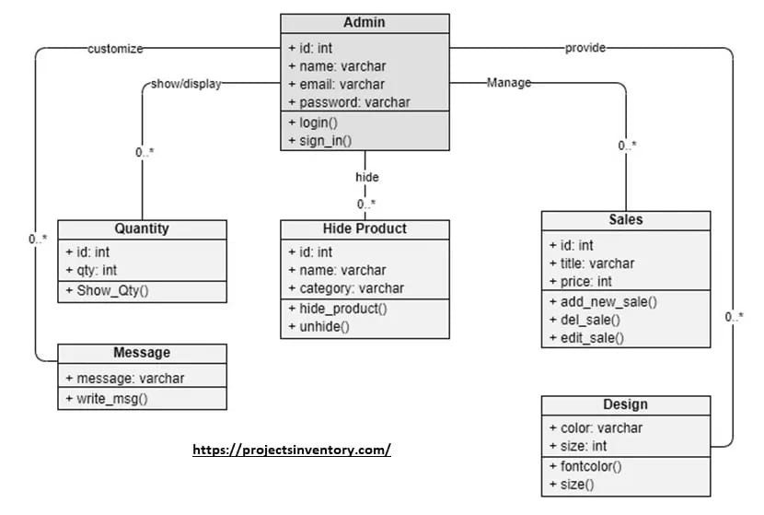

Fig 3.1:Class Diagram for personal portfolio

3.2 OBJECT DIAGRAM:

An object diagram in UML (Unified Modeling Language) is a diagram that depicts a specific
instance or snapshot of objects and their relationships within a system at a particular moment in
time. It illustrates the actual objects, their attributes, and the connections between them, providing
detailed view of the runtime structure of a software system.

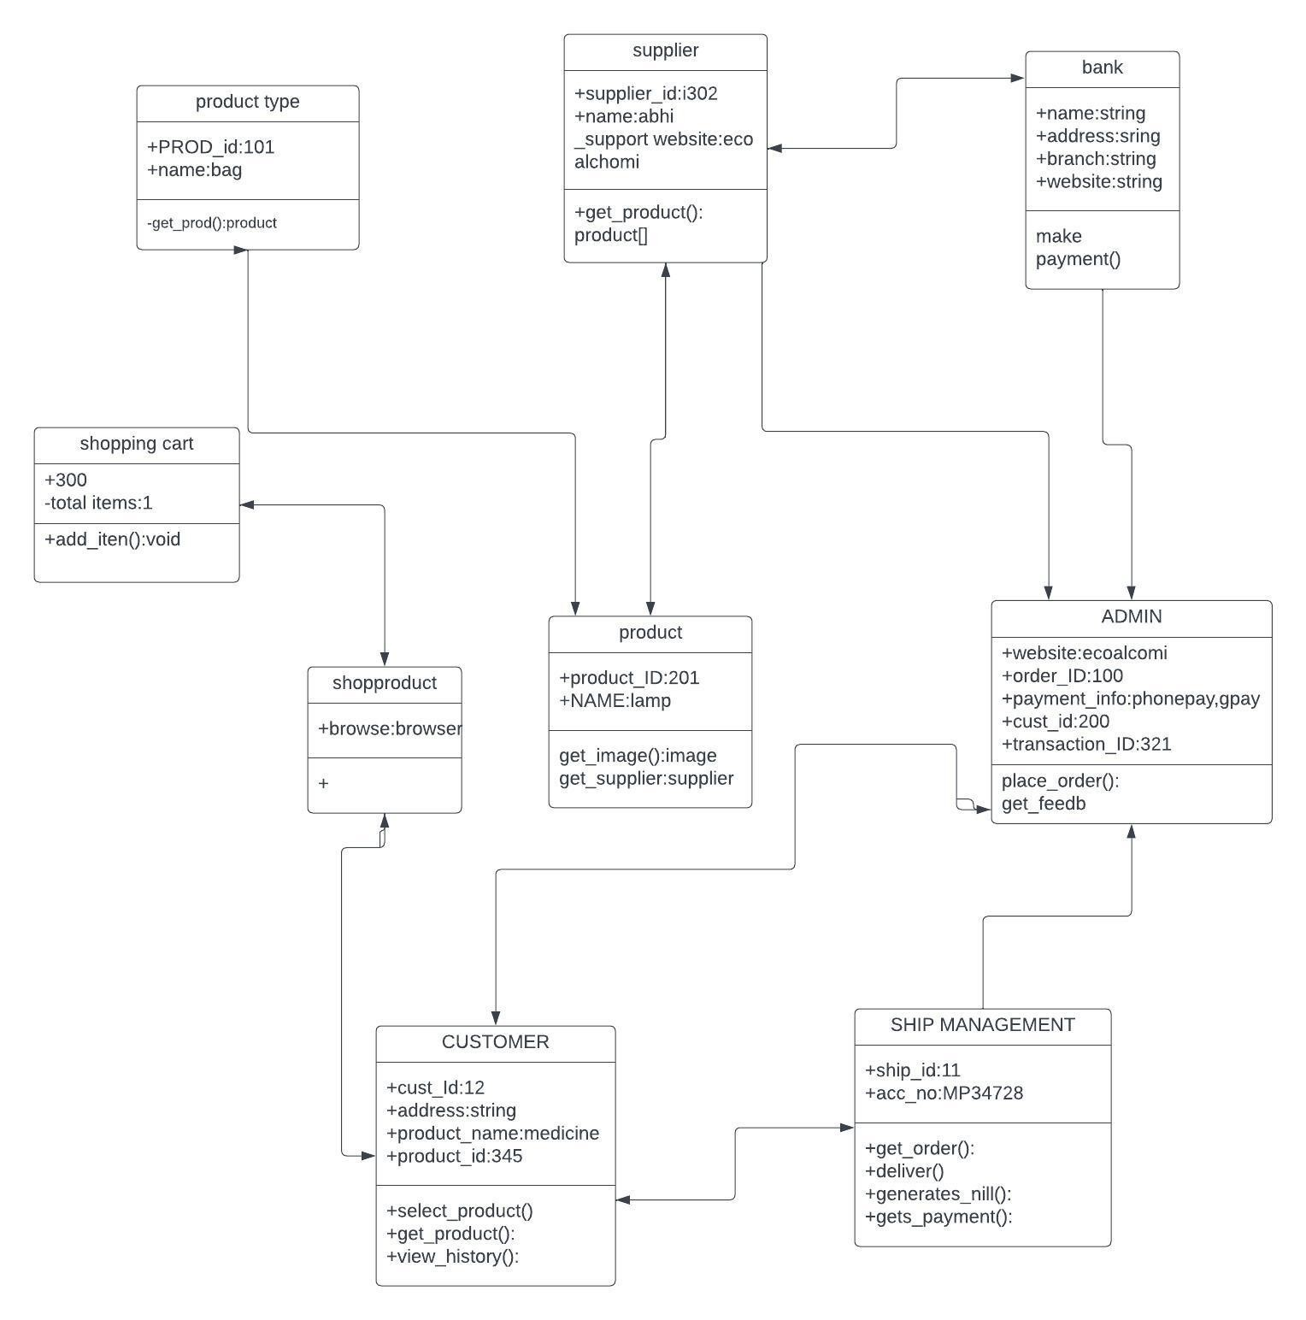
Fig 3.2:Object Diagram for E-Learning webiste

3.3 COMPONENT DIAGRAM:

Component diagrams are used in modeling the physical aspects of object-oriented systems that are used for visualizing, specifying, and documenting component-based systems and also for constructing executable systems through forward and reverse engineering.Component diagrams are essentially class diagrams that focus on a system's components that often used to model the static view of diagram.

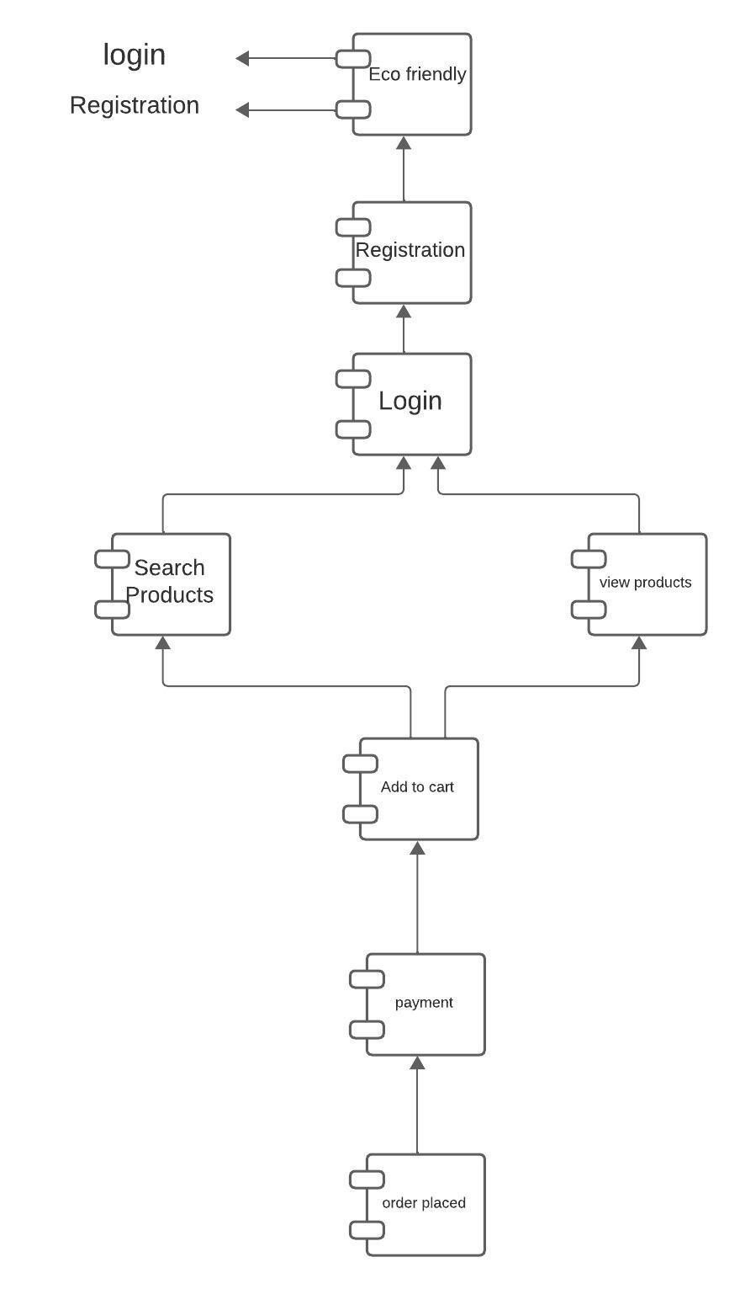

Fig 3.3:Component Diagram for E-Commerce webiste

CHAPTER 4 SOFTWARE ENVIRONMENT

Visual Studio Code (IDE)

Visual Studio Code, also commonly referred to as VS Code is a source-code editor made by Microsoft for Windows, Linux and macOS. Features include support for debugging, syntax highlighting, intelligent code completion, snippets, code refactoring, and embedded Git. Users can change the theme, keyboard shortcuts, preferences, and install extensions that add additional functionality.

CHROME OR ANY WEBBROWSER

A web browser is application software for accessing websites. When a user requests a web page from a particular website, the browser retrieves itsfiles from a web server and then displays the page on the user's screen. Browsers are used on a range of devices, including desktops, laptops, tablets, and smartphones.

  - SAMPLE CODE

CHAPTER - 5 IMPLEMENTATION

1.My Portfolio

Port.html

<!DOCTYPE html>

<html lang="en">

<head>

<!-- Google Tag Manager -->

<script>(function(w,d,s,l,i){w[l]=w[l]||[];w[l].push({'gtm.start':

new Date().getTime(),event:'gtm.js'});var f=d.getElementsByTagName(s)[0],

j=d.createElement(s),dl=l!='dataLayer'?'&l='+l:'';j.async=true;j.src=

'https://www.googletagmanager.com/gtm.js?id='+i+dl;f.parentNode.insertBefore(j,f);

})(window,document,'script','dataLayer','GTM-5BB8W2X');</script>

<!-- End Google Tag Manager -->

<link rel="icon" type="image/png" href="/favicon.png"/>

<meta charset="utf-8">

<meta content="width=device-width, initial-scale=1.0" name="viewport">

<title>Personal Portfolio</title>

<meta content="" name="descriptison">

<meta content="" name="keywords">

<!-- Google Fonts -->

<link href="https://fonts.googleapis.com/css?family=Open+Sans:300,300i,400,400i,600,600i,700,700i|Raleway:300,300i,400,400i,500,500i,600,600i,700,700i|Poppins:300,300i,400,400i,500,500i,600,600i,700,700i" rel="stylesheet">

<!-- Vendor CSS Files -->

<link href="assets/vendor/bootstrap/css/bootstrap.min.css" rel="stylesheet">

<link href="assets/vendor/icofont/icofont.min.css" rel="stylesheet">

<link href="assets/vendor/remixicon/remixicon.css" rel="stylesheet">

<link href="assets/vendor/owl.carousel/assets/owl.carousel.min.css" rel="stylesheet">

<link href="assets/vendor/boxicons/css/boxicons.min.css" rel="stylesheet">

<link href="assets/vendor/venobox/venobox.css" rel="stylesheet">

<!-- Template Main CSS File -->

<link href="assets/css/style.css" rel="stylesheet">

<script async src="https://www.googletagmanager.com/gtag/js?id=UA-169007209-3"></script>

<script>

window.dataLayer = window.dataLayer || [];

function gtag(){dataLayer.push(arguments);}

gtag('js', new Date());

gtag('config', 'UA-169007209-3');

</script>

</head>

<body>

<noscript><iframe src="https://www.googletagmanager.com/ns.html?id=GTM-5BB8W2X"

height="0" width="0" style="display:none;visibility:hidden"></iframe></noscript>

<header id="header" class="header-tops">

<div class="container">

<h1><a href="index.html">VALAVALA RAJESWARI</a></h1>

<!-- <h2 style="color:#fff">I'm <span class="typing" style="color:#12D640"></span></h2>-->

<nav class="nav-menu d-none d-lg-block">

<ul>

<li class="active"><a href="#header"> <span>Home</span></a></li>

<li><a href="#about"><span>About</span></a></li>

<li><a href="#education"> <span>Education</span></a></li>

<!-- <li><a href="#projects"> <span>Projects</span></a></li>-->

<li><a href="#portfolio"> <span>Projects</span></a></li>

<li><a href="#skills"> <span>Skills</span></a></li>

<li><a href="https://drive.google.com/file/d/1yJ8SqISPe3Uev8mjtsP4ijTG0X1TO6Uk/view?usp=drivesdk" target="_blank"> <span>Resume</span></a></li>

<!-- <li><a href="#links"> <span>Resume & Links</span></a></li> -->

<li><a href="#contacts"> <span>Contact</span></a></li>

</ul>

</nav><!-- .nav-menu -->

<div class="social-links">

<a href="https://www.linkedin.com/in/rajeswari-valavala-6963a6242" target="_blank" class="linkedin"><i class="bx bxl-linkedin"></i></a>

<a href="https://www.github.com/valavala28" target="_blank" class="github"><i class="bx bxl-github"></i></a>

<a href="mailto:rajivalavala28@gmail.com" target="_blank" class="google"><i class="bx bxl-google"></i></a>

</div>

</div>

</header><!-- End Header -->

<section id="about" class="about">

<!-- ======= About Me ======= -->

<div class="about-me container">

<div class="section-title">

<h2>About</h2>

</div>

<div class="row">

<div class="col-lg-4" data-aos="fade-right">

<img src="assets/img/profile.jpeg" class="img-fluid" alt="">

</div>

<div class="col-lg-8 pt-4 pt-lg-0 content" data-aos="fade-left">

<p>I'm Rajeswari Valavala, a seasoned web developer with a passion for creating engaging and seamless user

experiences. Proficient in HTML, CSS, REACT and JavaScript, with a keen eye for design and usability.

Experienced in collaborating with cross-functional teams to deliver high-quality, responsive web

applications.Iam an ideal fit for the role because of my deep understanding and hands-on experience with

front-end technologies like HTML, CSS, and JavaScript. My commitment to staying updated on industry

trends and my passion for creating visually appealing and intuitive user interfaces. Iam ability to collaborate

effectively with diverse teams, combined with a track record of delivering successful web applications,

showcases my dedication to achieving excellence in web development.

</p>

<div class="row">

<div class="col-lg-6">

<ul>

<li><i class="icofont-rounded-right"></i> <strong>Birthday:</strong> 13 Agust 2004</li>

<li><i class="icofont-rounded-right"></i> <strong>Phone:</strong> +91 8897019101</li>

</ul>

</div>

<div class="col-lg-6">

<ul>

<li><i class="icofont-rounded-right"></i> <strong>City:</strong> Ongole, Andhrapradesh</li>

<li><i class="icofont-rounded-right"></i> <strong>Email:</strong> rajivalavala28@gmail.com</li>

</ul>

</div>

</div>

</div>

</div>

</div><!-- End About Me -->

</section><!-- End About Section -->

<!-- ======= Education Section ======= -->

<section id="education" class="services">

<div class="container">

<div class="section-title">

<h2>Education</h2>

</div>

<div class="row">

<div class="col-lg-12" data-aos="fade-up" style="display: inline-block;">

<div class="col-md-4 mt-4 mt-md-0 icon-box" data-aos="fade-up" data-aos-delay="100" style="padding:0px 0px;padding-bottom: 5px;display: inline-block;">

<img src="assets/img/education/ASU.jpg" class="img-fluid" alt="">

<!-- <h4 style="text-align:left;"><a href="https://www.asu.edu/" target="_blank" style="color:#12d640">Arizona State University</a><br> </h4> -->

<p style="text-align:left;color:#fff;padding: 5px 10px;"><em>B.Tech in Computer Science And Engineering</em></p>

<h5 style="text-align:left;padding: 0px 10px;">June 2021 - Present</h5>

</div>

<div class="col-md-4 mt-4 mt-md-0 icon-box" data-aos="fade-up" data-aos-delay="100" style="padding:0px 0px;padding-bottom: 5px;display: inline-block;">

<img src="assets/img/education/au.png" class="img-fluid" alt="">

<!-- <h4 style="text-align:left;"><a href="https://ahduni.edu.in/" target="_blank" style="color:#12d640">Ahmedabad University</a><br> </h4> -->

<p style="text-align:left;color:#fff;padding: 5px 10px;"><em>Pre University Course</em></p>

<h5 style="text-align:left;padding: 0px 10px;">September 2019 - May 2021</h5>

</div>

</div>

</div>

</div>

<div class="portfolio">

<div class="container">

<div class="section-title">

<h2>Online Certification</h2>

</div>

<div class="row portfolio-container" style="position: relative; height: 437.75px;">

<div class="col-lg-4 col-md-6 portfolio-item filter-app" style="position: absolute; left: 0px; top: 0px;">

<div class="portfolio-wrap">

<img src="/home/rgukt/Downloads/valavala_rajeswari_portfolio/assets/img/certification/ybi.jpg" class="img-fluid" alt="">

<div class="portfolio-info">

<h4>AI & ML</h4>

<div class="portfolio-links">

<a href="https://drive.google.com/file/d/1vddltLncpnY7XL5lvKYJKFRONeoXK0Zp/view?usp=drivesdk" target="_blank" title="Certificate"><i class="bx bx-link"></i></a>

</div>

</div>

</div>

</div>

<div class="col-lg-4 col-md-6 portfolio-item filter-app" style="position: absolute; left: 370px; top: 0px;">

<div class="portfolio-wrap">

<img src="/home/rgukt/Downloads/valavala_rajeswari_portfolio/assets/img/certification/oib.jpg" class="img-fluid" alt="">

<div class="portfolio-info">

<h4>web development and desining</h4>

<div class="portfolio-links">

<a href="https://drive.google.com/file/d/1y6P1-v1IxXncR7YLRRxCR1nwiMuT2o_s/view?usp=drivesdk" target="_blank" title="Certificate"><i class="bx bx-link"></i></a>

</div>

</div>

</div>

</div>

<div class="col-lg-4 col-md-6 portfolio-item filter-app" style="position: absolute; left: 740px; top: 0px;">

<div class="portfolio-wrap">

<img src="/home/rgukt/Downloads/valavala_rajeswari_portfolio/assets/img/certification/great-learning.png" class="img-fluid" alt="">

<div class="portfolio-info">

<h4>MongoDB</h4>

<div class="portfolio-links">

<a href="https://drive.google.com/file/d/1vtymZuDHRA04jzd14l6VPQ723T_PSlI3/view?usp=drivesdk" target="_blank" title="Certificate"><i class="bx bx-link"></i></a>

</div>

</div>

</div>

</div>

<div class="col-lg-4 col-md-6 portfolio-item filter-project" style="position: absolute; left: 0px; top: 218.875px;">

<div class="portfolio-wrap">

<img src="assets/img/certification/ibm.jpg" class="img-fluid" alt="">

<div class="portfolio-info">

<h4>SQL</h4>

<div class="portfolio-links">

<a href="https://courses.edx.org/certificates/b4eac0002ae044ef9c1f51520f67d194" target="_blank" title="Certificate"><i class="bx bx-link"></i></a>

</div>

</div>

</div>

</div>

<div class="col-lg-4 col-md-6 portfolio-item filter-project" style="position: absolute; left: 370px; top: 218.875px;">

<div class="portfolio-wrap">

<img src="assets/img/certification/ibm.jpg" class="img-fluid" alt="">

<div class="portfolio-info">

<h4>Developing Front End Apps With React</h4>

<div class="portfolio-links">

<a href="https://courses.edx.org/certificates/4ea7697e06d54277baeb79b8ca6a1d08" target="_blank" title="Certificate"><i class="bx bx-link"></i></a>

</div>

</div>

</div>

</div>

<div class="col-lg-4 col-md-6 portfolio-item filter-project" style="position: absolute; left: 740px; top: 218.875px;">

<div class="portfolio-wrap">

<img src="assets/img/certification/ibm.jpg" class="img-fluid" alt="">

<div class="portfolio-info">

<h4>Analyzing Data With Excel</h4>

<div class="portfolio-links">

<a href="https://courses.edx.org/certificates/9972e0bb8f164aed8ac74199561e3588" target="_blank" title="Certificate"><i class="bx bx-link"></i></a>

</div>

</div>

</div>

</div>

</div>

</div>

</div>

</section>

<!-- End Education Section -->

<!-- Start Project Section -->

<section id="portfolio" class="portfolio">

<div class="container">

<div class="section-title">

<h2>Projects</h2>

</div>

<div class="row">

<div class="col-lg-12 d-flex justify-content-center">

<ul id="portfolio-flters">

<li data-filter="*" class="filter-active">All</li>

<li data-filter=".filter-app">Web-App</li>

<li data-filter=".filter-project">Project</li>

</ul>

</div>

</div>

<div class="row portfolio-container">

<div class="col-lg-4 col-md-6 portfolio-item filter-app">

<center><h4>Movie Recommender</h4></center>

<div class="portfolio-wrap">

<img src="assets/img/project/recommender.jpg" class="img-fluid" alt="">

<div class="portfolio-info">

<div class="portfolio-links">

<a href="projects/recommender.html" data-gall="portfolioDetailsGallery" data-vbtype="iframe" class="venobox" title="Project Details"><i class="bx bx-info-circle"></i></a>

</div>

</div>

</div>

</div>

<div class="col-lg-4 col-md-6 portfolio-item filter-app">

<center><h4>To-Do App</h4></center>

<div class="portfolio-wrap">

<img src="assets/img/project/todo.jpg" class="img-fluid" alt="">

<div class="portfolio-info">

<div class="portfolio-links">

<a href="projects/todo.html" data-gall="portfolioDetailsGallery" data-vbtype="iframe" class="venobox" title="Project Details"><i class="bx bx-info-circle"></i></a>

</div>

</div>

</div>

</div>

<div class="col-lg-4 col-md-6 portfolio-item filter-project filter-app">

<!-- <br> -->

<center><h4>Online Examination System</h4></center>

<div class="portfolio-wrap">

<img src="/home/rgukt/Downloads/valavala_rajeswari_portfolio/assets/img/project/online-exam-system.png" class="img-fluid" alt="">

<div class="portfolio-info">

<h4>Online Examination System</h4>

<div class="portfolio-links">

<a href="" data-gall="portfolioDetailsGallery" data-vbtype="iframe" class="venobox" title="Project Details"><i class="bx bx-info-circle"></i></a>

</div>

</div>

</div>

</div>

<div class="col-lg-4 col-md-6 portfolio-item filter-project">

<center><h4>Driver Drowsiness Detection</h4></center>

<div class="portfolio-wrap">

<img src="/home/rgukt/Downloads/valavala_rajeswari_portfolio/assets/img/project/ddd.jpg" class="img-fluid" alt="">

<div class="portfolio-info">

<div class="portfolio-links">

<a href="projects/vdg.html" data-gall="portfolioDetailsGallery" data-vbtype="iframe" class="venobox" title="Project Details"><i class="bx bx-info-circle"></i></a>

</div>

</div>

</div>

</div>

<section id="skills" class="services">

<div class="container">

<div class="section-title">

<h2>Skills</h2>

</div>

<div class="row">

<div class="col-lg-12" data-aos="fade-up">

<div class="col-md-12 mt-4 mt-md-0 icon-box" data-aos="fade-up" data-aos-delay="100" style="background:#fff">

<h4 style="text-align:left;color:#09203a">Languages and Databases</h4>

<p style="text-align:left;">

<img src="https://www.vectorlogo.zone/logos/python/python-horizontal.svg" alt="vectorlogo.zone" height="50" width="150">

<img src="https://www.vectorlogo.zone/logos/java/java-horizontal.svg" alt="vectorlogo.zone" height="50" width="120">

<img src="https://www.vectorlogo.zone/logos/w3_html5/w3_html5-ar21.svg" alt="vectorlogo.zone">

<img src="https://upload.wikimedia.org/wikipedia/commons/d/d5/CSS3_logo_and_wordmark.svg" alt="upload.wikimedia.org" height="60" width="90">

<img src="https://www.vectorlogo.zone/logos/mysql/mysql-horizontal.svg" alt="vectorlogo.zone" height="70" width="130">

<img src="https://upload.wikimedia.org/wikipedia/commons/9/93/MongoDB_Logo.svg" alt="vectorlogo.zone" height="50" width="190">

<img src="https://www.vectorlogo.zone/logos/javascript/javascript-horizontal.svg" alt="vectorlogo.zone" height="50" width="190">

</p>

</div>

<div class="col-md-12 mt-4 mt-md-0 icon-box" data-aos="lefade-up" data-aos-delay="100" style="background:#fff">

<h4 style="text-align:left;color:#09203a">Frameworks</h4>

<p style="text-align:left;">

<img src="https://www.vectorlogo.zone/logos/nodejs/nodejs-horizontal.svg" alt="vectorlogo.zone">

<img src="https://www.vectorlogo.zone/logos/getbootstrap/getbootstrap-ar21.svg" alt="vectorlogo.zone">

<img src="/home/rgukt/Downloads/reactjs-ar21.svg" alt="vectorlogo.zone">

</p>

</div>

<div class="col-md-12 mt-4 mt-md-0 icon-box" data-aos="lefade-up" data-aos-delay="100" style="background:#fff">

<h4 style="text-align:left;color:#09203a">Tools</h4>

<p style="text-align:left;">

<img src="https://www.vectorlogo.zone/logos/git-scm/git-scm-ar21.svg" alt="vectorlogo.zone">

<img src="https://www.vectorlogo.zone/logos/jupyter/jupyter-ar21.svg" alt="vectorlogo.zone">

</p>

</div>

</div>

</div>

</div>

</section>

<!-- End Skills Section -->

<!-- Start Links section -->

<section id="links" class="services">

<div class="container">

<div class="section-title">

<h2>Resume & Links</h2>

</div>

<div class="row">

<div class="col-md-3 mt-4 mt-md-0 icon-box" data-aos="fade-up" data-aos-delay="100">

<a href="https://drive.google.com/file/d/1yJ8SqISPe3Uev8mjtsP4ijTG0X1TO6Uk/view?usp=drivesdk" target="_blank"><div class="icon"><i class="icofont-page"></i></div></a>

<h4 class="title"><a href="https://drive.google.com/file/d/1yJ8SqISPe3Uev8mjtsP4ijTG0X1TO6Uk/view?usp=drivesdk" target="_blank">Resume</a></h4>

<section id="contacts" class="contact">

<div class="container">

<div class="section-title">

<h2>Contact</h2>

</div>

<div class="row mt-2">

<div class="col-md-6 d-flex align-items-stretch">

<div class="info-box">

<i class="bx bx-map"></i>

<h3>My Address</h3>

<p>Rajiv gandhi university of knowledge technologies</p>

<p>SSN santhanuthalapaadu</p>

<p>ongole, Andhrapradesh 523225</p>

</div>

</div>

<div class="col-md-6 mt-4 mt-md-0 d-flex align-items-stretch">

<div class="info-box">

<i class="bx bx-share-alt"></i>

<h3>Social Profiles</h3>

<div class="social-links">

<a href="https://www.linkedin.com/in/rajeswari-valavala-6963a6242" target="_blank" class="linkedin"><i class="bx bxl-linkedin"></i></a>

<a href="https://www.github.com/valavala28" target="_blank" class="github"><i class="bx bxl-github"></i></a>

<a href="mailto:rajivalavala28@gmail.com" target="_blank" class="google"><i class="bx bxl-google"></i></a>

</div>

</div>

</div>

<div class="col-md-6 mt-4 d-flex align-items-stretch">

<div class="info-box">

<i class="bx bx-envelope"></i>

<h3>Email</h3>

<p>rajivalavala28@gmail.com</p>

</div>

</div>

<div class="col-md-6 mt-4 d-flex align-items-stretch">

<div class="info-box">

<i class="bx bx-phone-call"></i>

<h3>Contact</h3>

<p>+91 8897019101</p>

</div>

</div>

</div>

</div>

</section>

<!-- End Contact Section -->

<!-- Vendor JS Files -->

<script src="assets/vendor/jquery/jquery.min.js"></script>

<script src="assets/vendor/bootstrap/js/bootstrap.bundle.min.js"></script>

<script src="assets/vendor/jquery.easing/jquery.easing.min.js"></script>

<script src="assets/vendor/php-email-form/validate.js"></script>

<script src="assets/vendor/waypoints/jquery.waypoints.min.js"></script>

<script src="assets/vendor/counterup/counterup.min.js"></script>

<script src="assets/vendor/owl.carousel/owl.carousel.min.js"></script>

<script src="assets/vendor/isotope-layout/isotope.pkgd.min.js"></script>

<script src="assets/vendor/venobox/venobox.min.js"></script>

<script src="assets/vendor/typed.js/typed.min.js"></script>

<script type="text/javascript">

var typed = new Typed('.typing',{

strings: ["Coder", "Developer", "AI Enthusiast"],

loop: true,

typeSpeed: 65,

backSpeed: 65

});

</script>

<!-- Template Main JS File -->

<script src="assets/js/main.js"></script>

</body>

</html>

2.E-COMMERCE

APP.JSX

import React from 'react'
import { BrowserRouter, Route, Routes, useLocation,Switch } from 'react-router-dom'
import Layout from './components/layout'
import Home from './pages/home'
import About from './pages/about'
import Shop from './pages/shop'
import Contact from './pages/contact'
import Login from './pages/login'
import Signup from './pages/signup'
import Forgotpasword from './pages/forgotpasword'
import Cart from './pages/cart'
import Checkout from './pages/checkout'
import Blog from './pages/blog'
import './App.css'
import ShopContext from './components/shopcontext'
import Details from './pages/details'

function ScrollToTop() {
const { pathname } = useLocation();

React.useEffect(() => {
window.scrollTo(0, 0);
}, [pathname]);

return null;
}

function App() {

return (
<>
<ShopContext>
<BrowserRouter>
<ScrollToTop />
<Routes>
<Route path='/' element={<Layout />}>
<Route index element={<Home />} />
<Route path='shop' element={<Shop />} />
<Route path='blog' element={<Blog />} />
<Route path='about' element={<About />} />
<Route path='contact' element={<Contact />} />
<Route path='login' element={<Login />} />
<Route path='signup' element={<Signup />} />
<Route path='forgotpasword' element={<Forgotpasword />} />
<Route path='cart' element={<Cart />} />
<Route path='checkout' element={<Checkout />} />
<Route path='details' element={<Details />} />
</Route>
</Routes>
</BrowserRouter>
</ShopContext>
</>
)
}

export default App

LOGIN.JSX

import React, { useState } from 'react';
import { Link } from 'react-router-dom';
import axios from 'axios';

const Login = () => {
const [data, setData] = useState({
email: '',
password: '',
});

const [error, setError] = useState(null); // Initialize error state

const { email, password } = data;

const changeHandler = (e) => {
setData({ ...data, [e.target.name]: e.target.value });
};

const submitHandler = (e) => {
e.preventDefault();
axios.post('http://localhost:5001/login', data)
.then((res) => {
alert(res.data);
// Handle other logic after a successful response if needed
})
.catch((error) => {
setError('User not found.'); // Set error state
console.error('Error:', error);
});
};

return (
<section className="login-wrapper p-5">
<div className="container-xxl">
<div className="row justify-content-center">
<div className="col-lg-4 col-md-8 col-sm-10">
<div className="card">
<div className="card-body p-5">
<h2 className="text-center">LOGIN</h2>
<p className="text-center mb-4">Welcome Back!!</p>
<form onSubmit={submitHandler}>
<div className="mb-3">
<label htmlFor="email" className="form-label mb-3">
Enter Your Email address
</label>
<input
type="email"
className="form-control"
id="email"
placeholder="enter email here ..."
value={email}
onChange={changeHandler}
name="email"
required
/>
</div>
<div className="mb-3">
<label htmlFor="password" className="form-label mb-3">
Enter Your password
</label>
<input
type="password"
className="form-control"
id="password"
placeholder="enter password here..."
value={password}
onChange={changeHandler}
name="password"
required
/>
</div>
{/* Display error message */}
{error && (
<div className="alert alert-danger">{error}</div>
)}

{/* Forgot password and Signup links */}
<div className="mb-3">
<Link to="/forgotpassword" className="form-link">
Forgot password?
</Link>
</div>
<div className="d-flex justify-content-between align-items-center mb-3">
<p className='m-0'>Don't have an account?</p>
<Link to="/signup" className="form-link">
Sign up
</Link>
</div>

{/* Submit button */}
<div className="d-grid gap-2">
<button type="submit">Login</button>
</div>
</form>
</div>
</div>
</div>
</div>
</div>
</section>
);
};

export default Login;

SHOP.JSX

import React, { useContext } from 'react'
import Shopitems from '../components/shopitems';
import Newsletter from '../components/newsletter';
import Hero from '../components/hero'

const shop = () => {
return <>
<section className="shop-banner p-5">
<div className="container-xxl">
<div className="row justify-content-center align-items-center">
<div className="col-md-8 col-lg-6 text-center">
<div className="shop-details">
<h1 className="text-white"><b className="title-green">#100%</b> Off On All Products</h1>
<p className="text-white fs-5">Make your orders we will deliver..</p>
</div>
</div>
</div>
</div>
</section>

<section className="featured-products p-5">
<div className="container-xxl">
<div className="row">
<Shopitems />
</div>
</div>
</section>

<section className="pagination p-2">
<div className="container-xxl">
<div className="row">
<div className="col-12 align-items-center justify-content-center">
<nav aria-label="Page navigation example">
<ul className="pagination justify-content-center">
<li className="page-item">
<a className="page-link" href="#" aria-label="Previous">
<span aria-hidden="true">&laquo;</span>
</a>
</li>
<li className="page-item"><a className="page-link" href="#">1</a></li>
<li className="page-item"><a className="page-link" href="#">2</a></li>
<li className="page-item"><a className="page-link" href="#">3</a></li>
<li className="page-item">
<a className="page-link" href="#" aria-label="Next">
<span aria-hidden="true">&raquo;</span>
</a>
</li>
</ul>
</nav>
</div>
</div>
</div>
</section>
<Hero />

<Newsletter />
</>;
}

export default shop

3.E-Learning

El.html
<!DOCTYPE html>
<html lang="en">

<head>
<meta charset="UTF-8">
<meta http-equiv="X-UA-Compatible" content="IE=edge">
<meta name="viewport" content="width=device-width, initial-scale=1.0">
<script src="https://kit.fontawesome.com/4dcdb6ddc3.js" crossorigin="anonymous"></script>
<link rel="stylesheet" href="/home/rgukt/Downloads/triangle-elearning-main/bootstarp/bootstrap.min.css">
<link rel="stylesheet" href="/home/rgukt/Downloads/triangle-elearning-main/style.css">
<link rel="shortcut icon" href="/home/rgukt/Downloads/triangle-elearning-main/images/fav.png" type="image/x-icon">
<script src="https://kit.fontawesome.com/4dcdb6ddc3.js" crossorigin="anonymous"></script>
<title>Triangle eLearning</title>
</head>

<body>

<header>
<!-- Navbar Menu -->
<nav class="container navbar navbar-expand-lg bg-white navbar-black font-weight-bold p-2">
<div class="container-fluid ms-lg-5">
<a class="navbar-brand" href="#">
<h3>Triangle eLearning</h3>
</a>
<button class="navbar-toggler" type="button" data-bs-toggle="collapse" data-bs-target="#navbarNav"
aria-controls="navbarNav" aria-expanded="false" aria-label="Toggle navigation">
<span class="navbar-toggler-icon"></span>
</button>
<div class="collapse navbar-collapse flex-row-reverse " id="navbarNav">
<ul class="navbar-nav align-items-center">
<li class="nav-item">
<a class="nav-link active" aria-current="page" href="#">Home</a>
</li>
<li class="nav-item">
<a class="nav-link active" aria-current="page" href="#course">Courses</a>
</li>
<li class="nav-item">
<a class="nav-link active" aria-current="page" href="#institute">Institute</a>
</li>
<li class="nav-item">
<a class="nav-link active" aria-current="page" href="#Students">Students</a>
</li>
<li class="nav-item">
<a class="nav-link active" aria-current="page" href="#faq">FAQ</a>
</li>
<li class="nav-item">
<a class="nav-link active" aria-current="page" href="#join"><Button
class="btn btn-primary text-white">Register</Button></a>
</li>
</ul>
</div>
</div>
</nav>

<!-- slider-section -->

<div id="carouselExampleCaptions" class="container carousel slide mb-5" data-bs-ride="true">
<div class="carousel-indicators">
<button type="button" data-bs-target="#carouselExampleCaptions" data-bs-slide-to="0" class="active"
aria-current="true" aria-label="Slide 1"></button>
<button type="button" data-bs-target="#carouselExampleCaptions" data-bs-slide-to="1"
aria-label="Slide 2"></button>
<button type="button" data-bs-target="#carouselExampleCaptions" data-bs-slide-to="2"
aria-label="Slide 3"></button>
</div>
<div class="carousel-inner">
<div class="carousel-item active" data-bs-interval="2000">
<img src="/home/rgukt/Downloads/triangle-elearning-main/images/cover/cover-1.png" class="d-block w-100" alt="...">
<div class="carousel-caption">
<h2>Triangle E-Learning Academy</h2>
<p class="d-lg-block d-none">Find the right instructor for you. Choose from many topics, skill
levels,
and
languages.
</p>
<a class="btn btn-primary ps-4 pe-4" href="https://www.udemy.com/" role="button">Get Started</a>
</div>
</div>
<div class="carousel-item" data-bs-interval="2000">
<img src="/home/rgukt/Downloads/triangle-elearning-main/images/cover/cover-3.jpg" class="d-block w-100 item" alt="...">
<div class="carousel-caption d-none d-md-block">
<h2>Triangle E-Learning Academy</h2>
<p>Find the right instructor for you. Choose from many topics, skill levels, and languages.
</p>
<a class="btn btn-primary ps-4 pe-4" href="https://www.udemy.com/" role="button">Get Started</a>

</div>
</div>
<div class="carousel-item" data-bs-interval="2000">
<img src="/home/rgukt/Downloads/triangle-elearning-main/images/cover/cover-2.jpg" class="d-block w-100 item" alt="...">
<div class="carousel-caption d-none d-md-block">
<h2>Triangle E-Learning Academy</h2>
<p>Find the right instructor for you. Choose from many topics, skill levels, and languages.
</p>
<a class="btn btn-primary ps-4 pe-4" href="https://www.udemy.com/" role="button">Get
Started</a>>

</div>
</div>
</div>

<button class="carousel-control-prev" type="button" data-bs-target="#carouselExampleCaptions"
data-bs-slide="prev">
<span class="carousel-control-prev-icon" aria-hidden="true"></span>
<span class="visually-hidden">Previous</span>
</button>
<button class="carousel-control-next" type="button" data-bs-target="#carouselExampleCaptions"
data-bs-slide="next">
<span class="carousel-control-next-icon" aria-hidden="true"></span>
<span class="visually-hidden">Next</span>
</button>
</div>

</header>

<main>

<!-- Course Section -->
<section class="container" id="course">
<div class="text-center mb-5">
<h2>Discover Our Popular
Courses</h2>
<p class="p-2 p-lg-0">It is a long established fact that a reader will be distracted by the readable
content of <br> a page when looking at its layout</p>
</div>
<div class="row row-cols-1 row-cols-md-1 row-cols-lg-2 justify-content-between gy-5 gx-0">

<div class="card flex-md-row col-lg-6">
<img class="p-2" src="/home/rgukt/Downloads/triangle-elearning-main/images/course/course-1.png" />
<div class="card-body">
<h4 class="card-title">Fundamental Of UI/UX Design</h4>
<p class="card-text text-muted">The five main principles of UX design. There are many
important
principles within UX design.</p>
<h4 class="text-primary">Price: $220</h4>
</div>
</div>
<div class="card flex-md-row col-lg-5">
<img class="p-2" src="/home/rgukt/Downloads/triangle-elearning-main/images/course/course-2.png" />
<div class="card-body">
<h4 class="card-title">Fullstack Web Development</h4>
<p class="card-text text-muted">The five main principles of UX design. There are many
important
principles within UX design.</p>
<h4 class="text-primary">Price: $220</h4>
</div>
</div>
<div class="card flex-md-row col-lg-6">
<img class="p-2" src="/home/rgukt/Downloads/triangle-elearning-main/images/course/course-3.png" />
<div class="card-body">
<h4 class="card-title">Fullstack Web Dev</h4>
<p class="card-text text-muted">The five main principles of UX design. There are many
important
principles within UX design.</p>
<h4 class="text-primary">Price: $220</h4>
</div>
</div>
<div class="card flex-md-row col-lg-5">
<img class="p-2" src="/home/rgukt/Downloads/triangle-elearning-main/images/course/course-4.png" />
<div class="card-body">
<h4 class="card-title">Digital Marketing</h4>
<p class="card-text text-muted">The five main principles of UX design. There are many
important
principles within UX design.</p>
<h4 class="text-primary">Price: $220</h4>
</div>
</div>
<div class="card flex-md-row col-lg-6">
<img class="p-2" src="/home/rgukt/Downloads/triangle-elearning-main/images/course/course-5.png" />
<div class="card-body">
<h4 class="card-title">Photography Basic Rules</h4>
<p class="card-text text-muted">The five main principles of UX design. There are many
important
principles within UX design.</p>
<h4 class="text-primary">Price: $220</h4>
</div>
</div>
<div class="card flex-md-row col-lg-5">
<img class="p-2" src="/home/rgukt/Downloads/triangle-elearning-main/images/course/course-6.png" />
<div class="card-body">
<h4 class="card-title">Motion Graphics</h4>
<p class="card-text text-muted">The five main principles of UX design. There are many
important
principles within UX design.</p>
<h4 class="text-primary">Price: $220</h4>
</div>
</div>

</div>
<!-- <div class="col text-center ms-lg-5">
<button class="btn btn-primary mt-5 mb-5">See More Courses</button>
</div> -->
<nav aria-label="Page navigation example ">
<ul class="pagination justify-content-center mt-5">
<li class="page-item disabled">
<a class="page-link">Previous</a>
</li>
<li class="page-item"><a class="page-link" href="#">1</a></li>
<li class="page-item"><a class="page-link" href="#">2</a></li>
<li class="page-item"><a class="page-link" href="#">3</a></li>
<li class="page-item">
<a class="page-link" href="#">Next</a>
</li>
</ul>
</nav>
<!-- Explore Institute -->

<div class="card flex-lg-row mt-5" id="institute">
<img class="p-2 img-fluid" src="/home/rgukt/Downloads/triangle-elearning-main/images/working.png" />
<div class="card-body">
<h1 class="card-title">Explore The elearning
Institute</h1>
<p class="card-text text-muted p-2 about">Those who achieve the most in life are always
learning.They are students of life, students of their mentors, students of their peers, and students of their experiences. Their 'cups are empty', always ready to learn. <br> <br> They seek to improve themselves at every turn. Following the concept of RYTHM, they strive to raise themselves in every way, for the benefit of themselves and those around them.At the Swiss eLearning Institute, courses are designed for these types of people; both those who aspire to achieve and those who are already achieving.<br> <br> The thirst for learning and personal development lives in everyone but is especially evident in networkers. Investing in your future goes beyond financial gain. Investing in your future is investing in yourself; enhancing your personal knowledge and continuing education</p>
<div class="d-flex justify-content-between">
<div>
<h2 class="fs-1">3.2k+</h2>
<p class="text-muted">Online Course</p>
</div>
<div>
<h2 class="fs-1">600+</h2>
<p class="text-muted">Active Members</p>
</div>
<div>
<h2 class="fs-1">1k+</h2>
<p class="text-muted">Rating & Review</p>
</div>
</div>
<button class="btn btn-primary">Read More..</button>
</div>
</div>

</section>

<!-- Ready to join -->
<section class="container" id="join">
<div class="card flex-lg-row bg-primary text-white p-3 p-lg-5 mt-5 mb-5 text-lg-start text-center">

<div class="card-body d-flex flex-lg-row flex-column justify-content-between align-items-center">
<div>
<h1 class="card-title">Ready to join?</h1>
<p class="card-text text-white-50">It is a long established fact that a reader will be
distracted by the <br>
readable content of a page when looking at its layout.
</p>
</div>

<!-- Modal start -->
<button type="button" class="btn btn-primary mt-3 mt-lg-0 bg-white text-primary"
data-bs-toggle="modal" data-bs-target="#staticBackdrop">
Register Now
</button>

<div class="modal fade" id="staticBackdrop" data-bs-backdrop="static" data-bs-keyboard="false"
tabindex="-1" aria-labelledby="staticBackdropLabel" aria-hidden="true">
<div class="modal-dialog">
<div class="modal-content">
<div class="modal-header">
<h5 class="modal-title text-primary" id="staticBackdropLabel">Learn with us</h5>
<button type="button" class="btn-close" data-bs-dismiss="modal"
aria-label="Close"></button>
</div>
<div class="modal-body text-black">
<p>Need Help with registration? Log In or Create a User Account. Contact us if you
need technical help.</p>
</div>
<div class="modal-footer">
<button type="button" class="btn btn-secondary"
data-bs-dismiss="modal">Close</button>
<button type="button" class="btn btn-primary">Registration</button>
</div>
</div>
</div>
</div>

</div>
</div>
</section>

<!-- Student Section -->

<section class="container" id="Students">
<div>
<h1>
Meet Our Successful
Students
</h1>
<p class="text-muted">Your story is unique. That's why we work closely with you to understand your
particular interests,
needs, and aspirations.</p>
</div>

<div class="row row-cols-1 row-cols-md-2 row-cols-lg-4 g-4">
<div class="col">
<div class="card h-100">
<img src="/home/rgukt/Downloads/triangle-elearning-main/images/student/student-1.png" class="card-img-top" alt="Student Picture">
<div class="card-body">
<h5 class="card-title">Saad Ahmed</h5>
<p class="card-text text-muted">Full-Stack Developer</p>
</div>
</div>
</div>
<div class="col">
<div class="card h-100">
<img src="/home/rgukt/Downloads/triangle-elearning-main/images/student/student-2.png" class="card-img-top" alt="Student Picture">
<div class="card-body">
<h5 class="card-title">Samia Ahmed</h5>
<p class="card-text text-muted">Full-Stack Developer</p>
</div>
</div>
</div>
<div class="col">
<div class="card h-100">
<img src="/home/rgukt/Downloads/triangle-elearning-main/images/student/student-3.png" class="card-img-top" alt="Student Picture">
<div class="card-body">
<h5 class="card-title">Aminul Ahmed</h5>
<p class="card-text text-muted">Full-Stack Developer</p>
</div>
</div>
</div>
<div class="col">
<div class="card h-100">
<img src="/home/rgukt/Downloads/triangle-elearning-main/images/student/student-4.png" class="card-img-top" alt="Student Picture">
<div class="card-body">
<h5 class="card-title">Ayesha Ahmed</h5>
<p class="card-text text-muted">Full-Stack Developer</p>
</div>
</div>
</div>

</section>
<div class="col-12 text-center">
<button class="btn btn-primary mt-5 mb-5">View All</button>
</div>

<!-- Students Feedback -->
<section class="container">

<div class="text-center mb-5">
<h1>
Some Students Feedback
</h1>
<p class="text-muted">Give your own feedback Your story is unique. That's why we work closely with you
to understand your
particular interests,
needs, and aspirations.</p>
</div>

<div id="carouselExampleControls" class="carousel slide" data-bs-ride="carousel">
<div class="carousel-inner">
<div class="carousel-item active">
<div class="row row-cols-1 row-cols-md-1 row-cols-lg-2 justify-content-between gy-5 gx-0 mb-5">

<div class="card flex-md-row col-lg-6">
<div class="card-header bg-transparent border-light">
<div> <i class="fa-solid fa-quote-right fa-2xl text-muted"></i></div>
</div>
<div class="card-body">
<p class="card-text text-muted">Students feel more noticed when their teachers give them feedback. This provides a stronger connection between teacher and student.Feedback can come in all</p>

<div class="d-flex justify-content-center align-items-center align-content-center">
<div> <img src="/home/rgukt/Downloads/triangle-elearning-main/images/student/student-5.png" alt=""></div>
<div class="p-3 mt-3">
<h5 class="text-primary">Steve Jobs</h5>
<p>Software Engineer</p>
<div class="d-flex">
<p>Rating:

<i class="fa-solid fa-star fa-sm text-warning"></i>
<i class="fa-solid fa-star fa-sm text-warning"></i>
<i class="fa-solid fa-star fa-sm text-warning"></i>
<i class="fa-solid fa-star fa-sm text-warning"></i>
<i class="fa-solid fa-star fa-sm text-warning"></i>
</p>
</div>

</div>
</div>
</div>
</div>
<div class="card flex-md-row col-lg-5">
<div class="card-header bg-transparent border-light">
<div> <i class="fa-solid fa-quote-right fa-2xl text-muted"></i></div>
</div>
<div class="card-body">
<p class="card-text text-muted">Students feel more noticed when their teachers give
them
feedback. This provides a stronger connection between teacher and student.
Feedback can come
in all</p>

<div class="d-flex justify-content-center align-items-center align-content-center">
<div> <img src="/home/rgukt/Downloads/triangle-elearning-main/images/student/student-6.png" alt=""></div>
<div class="p-3 mt-3">
<h5 class="text-primary">Aliza Ahmed</h5>
<p>Entrepreneur and Developer</p>
<div class="d-flex">
<p>Rating:

<i class="fa-solid fa-star fa-sm text-warning"></i>
<i class="fa-solid fa-star fa-sm text-warning"></i>
<i class="fa-solid fa-star fa-sm text-warning"></i>
<i class="fa-solid fa-star fa-sm text-warning"></i>
<i class="fa-solid fa-star fa-sm text-warning"></i>
</p>
</div>

</div>
</div>
</div>
</div>
</div>
</div>
<div class="carousel-item">
<div class="row row-cols-1 row-cols-md-1 row-cols-lg-2 justify-content-between gy-5 gx-0 mb-5">

<div class="card flex-md-row col-lg-6">
<div class="card-header bg-transparent border-light">
<div> <i class="fa-solid fa-quote-right fa-2xl text-muted"></i></div>
</div>
<div class="card-body">
<p class="card-text text-muted">Students feel more noticed when their teachers give
them
feedback. This provides a stronger connection between teacher and student.
Feedback can come
in all</p>

<div class="d-flex justify-content-center align-items-center align-content-center">
<div> <img src="/home/rgukt/Downloads/triangle-elearning-main/images/student/student-6.png" alt=""></div>
<div class="p-3 mt-3">
<h5 class="text-primary">Samia Ahmed</h5>
<p>Software Engineer</p>
<div class="d-flex">
<p>Rating:

<i class="fa-solid fa-star fa-sm text-warning"></i>
<i class="fa-solid fa-star fa-sm text-warning"></i>
<i class="fa-solid fa-star fa-sm text-warning"></i>
<i class="fa-solid fa-star fa-sm text-warning"></i>
<i class="fa-solid fa-star fa-sm text-warning"></i>
</p>
</div>

</div>
</div>
</div>
</div>
<div class="card flex-md-row col-lg-5">
<div class="card-header bg-transparent border-light">
<div> <i class="fa-solid fa-quote-right fa-2xl text-muted"></i></div>
</div>
<div class="card-body">
<p class="card-text text-muted">Students feel more noticed when their teachers give them feedback. This provides a stronger connection between teacher and student. Feedback can come in all</p><div class="d-flex justify-content-center align-items-center align-content-center">
<div> <img src="/home/rgukt/Downloads/triangle-elearning-main/images/student/student-5.png" alt=""></div><div class="p-3 mt-3"> <h5 class="text-primary">Saad Ahmed</h5>
<p>Entrepreneur and Developer</p>
<div class="d-flex">
<p>Rating:

<i class="fa-solid fa-star fa-sm text-warning"></i>
<i class="fa-solid fa-star fa-sm text-warning"></i>
<i class="fa-solid fa-star fa-sm text-warning"></i>
<i class="fa-solid fa-star fa-sm text-warning"></i>
<i class="fa-solid fa-star fa-sm text-warning"></i>
</p>
</div>

</div>
</div>
</div>
</div>
</div>
</div>
<div class="carousel-item">
<div class="row row-cols-1 row-cols-md-1 row-cols-lg-2 justify-content-between gy-5 gx-0 mb-5">

<div class="card flex-md-row col-lg-6">
<div class="card-header bg-transparent border-light">
<div> <i class="fa-solid fa-quote-right fa-2xl text-muted"></i></div>
</div>
<div class="card-body">
<p class="card-text text-muted">Students feel more noticed when their teachers give them feedback. This provides a stronger connection between teacher and student.Feedback can come in all</p> <div class="d-flex justify-content-center align-items-center align-content-center"><div> <img src="/home/rgukt/Downloads/triangle-elearning-main/images/student/student-5.png" alt=""></div>
<div class="p-3 mt-3">
<h5 class="text-primary">Steve Jobs</h5>
<p>Software Engineer</p>
<div class="d-flex">
<p>Rating:

<i class="fa-solid fa-star fa-sm text-warning"></i>
<i class="fa-solid fa-star fa-sm text-warning"></i>
<i class="fa-solid fa-star fa-sm text-warning"></i>
<i class="fa-solid fa-star fa-sm text-warning"></i>
<i class="fa-solid fa-star fa-sm text-warning"></i>
</p>
</div>

</div>
</div>
</div>
</div>
<div class="card flex-md-row col-lg-5">
<div class="card-header bg-transparent border-light">
<div> <i class="fa-solid fa-quote-right fa-2xl text-muted"></i></div>
</div>
<div class="card-body">
<p class="card-text text-muted">Students feel more noticed when their teachers give themfeedback. This provides a stronger connection between teacher and student. Feedback can come in all</p>

<div class="d-flex justify-content-center align-items-center align-content-center">
<div> <img src="/home/rgukt/Downloads/triangle-elearning-main/images/student/student-6.png" alt=""></div>
<div class="p-3 mt-3">
<h5 class="text-primary">Aliza Ahmed</h5>
<p>Entrepreneur and Developer</p>
<div class="d-flex">
<p>Rating:

<i class="fa-solid fa-star fa-sm text-warning"></i>
<i class="fa-solid fa-star fa-sm text-warning"></i>
<i class="fa-solid fa-star fa-sm text-warning"></i>
<i class="fa-solid fa-star fa-sm text-warning"></i>
<i class="fa-solid fa-star fa-sm text-warning"></i>
</p>
</div>

</div>
</div>
</div>
</div>
</div>
</div>
</div>
<button class="carousel-control-prev text-black" type="button" data-bs-target="#carouselExampleControls"
data-bs-slide="prev">
<span class="carousel-control-prev-icon bg-primary mb-5 mb-lg-0 me-md-5" aria-hidden="true"></span>
</button>
<button class="carousel-control-next" type="button" data-bs-target="#carouselExampleControls"
data-bs-slide="next">
<span class="carousel-control-next-icon bg-primary mb-5 mb-lg-0 ms-md-5" aria-hidden="true"></span>
</button>
</div>
</section>

<!-- Frequently ask Questions -->

<section class="container" id="faq">

<div class="text-center mb-5">
<h1>
Frequently Asked Questions
</h1>
<p class="text-muted p-5">Frequently asked question (FAQ) pages not only serve as a way for youraudience to quickly find answers to the questions that they many have.</p>
</div>

<div class="accordion mb-5 p-md-5" id="accordionExample">
<div class="accordion-item">
<h2 class="accordion-header" id="headingOne">
<button class="accordion-button" type="button" data-bs-toggle="collapse"
data-bs-target="#collapseOne" aria-expanded="true" aria-controls="collapseOne">
What is the core difference in between Grid & Flex?
</button>
</h2>
<div id="collapseOne" class="accordion-collapse collapse show" aria-labelledby="headingOne"
data-bs-parent="#accordionExample">
<div class="accordion-body">
<strong>Grid and flexbox. </strong> The basic difference between CSS Grid Layout and CSS Flexbox Layout is that flexbox was designed for layout in one dimension - either a row or a
column. Grid was designed for two-dimensional layout - rows, and columns at the same time.
</div>
</div>
</div>
<div class="accordion-item">
<h2 class="accordion-header" id="headingTwo">
<button class="accordion-button collapsed" type="button" data-bs-toggle="collapse"
data-bs-target="#collapseTwo" aria-expanded="false" aria-controls="collapseTwo">
What is CSS box Model?
</button>
</h2>
<div id="collapseTwo" class="accordion-collapse collapse" aria-labelledby="headingTwo"
data-bs-parent="#accordionExample">
<div class="accordion-body">
<strong>CSS box model </strong> refers to how HTML elements are modeled in browser engines and how the dimensions of those HTML elements are derived from CSS properties. It is a fundamental concept for the composition of HTML webpages.
</div>
</div>
</div>
<div class="accordion-item">
<h2 class="accordion-header" id="headingThree">
<button class="accordion-button collapsed" type="button" data-bs-toggle="collapse"
data-bs-target="#collapseThree" aria-expanded="false" aria-controls="collapseThree">
What is difference in between Bootstrap and Tailwind CSS Framework?
</button>
</h2>
<div id="collapseThree" class="accordion-collapse collapse" aria-labelledby="headingThree"
data-bs-parent="#accordionExample">
<div class="accordion-body">
Bootstrap comes with a set of pre-styled responsive, mobile-first components that
possess a definite UI kit. Tailwind CSS uses a set of utility classes to create a neat
UI with more flexibility and uniqueness. Sites created using Bootstrap follow the
generic pattern that makes them look identical.
</div>
</div>
</div>
<div class="accordion-item">
<h2 class="accordion-header" id="headingFour">
<button class="accordion-button collapsed" type="button" data-bs-toggle="collapse"
data-bs-target="#collapseFour" aria-expanded="false" aria-controls="collapseFour">
What is semantic element with example?
</button>
</h2>
<div id="collapseFour" class="accordion-collapse collapse " aria-labelledby="headingFour"
data-bs-parent="#accordionExample">
<div class="accordion-body">
A semantic element clearly describes its meaning to both the browser and the developer.
Examples of non-semantic elements: div and span - Tells nothing about its content.
Examples of semantic elements: form , table , and article - Clearly defines
its content.
</div>
</div>
</div>
</div>
</section>

<!-- Trusted Companies -->
<section class="container d-none d-lg-block">

<div class="text-center mb-5">
<h1>
Trusted by over 800+ companies
</h1>
</div>

<div class="d-flex justify-content-between mb-5 g-5">

<img src="/images/company/company-1.png" alt="Companies Logo">
<img src="/images/company/company-2.png" alt="Companies Logo">
<img src="/images/company/company-3.png" alt="Companies Logo">
<img src="/images/company/company-4.png" alt="Companies Logo">
<img src="/images/company/company-5.png" alt="Companies Logo">
<img src="/images/company/company-6.png" alt="Companies Logo">

</div>
</section>
</main>

<footer class="h-250 bg-black text-white p-5 ">

<div class="text-center">
<h1>
Triangle E-Learning
</h1>
<p>Sector 10, Uttara Dhaka 1230 <br> Bangladesh</p>
<p>
Privacy Policy | Terms of use
</p> <br>
<a href="https://www.facebook.com/Engr.Saad.2/"> <i
class="fa-brands fa-facebook-square text-white fa-2xl m-2"></i></a>
<a href="https://www.facebook.com/Engr.Saad.2/"> <i
class="fa-brands fa-instagram-square text-white fa-2xl m-2"></i></a>
<a href="https://www.facebook.com/Engr.Saad.2/"> <i
class="fa-brands fa-twitter-square text-white fa-2xl m-2"></i></a>
<a href="https://www.facebook.com/Engr.Saad.2/"> <i
class="fa-brands fa-linkedin m-2 text-white fa-2xl"></i></a>

</div>
</footer>
<script src="/home/rgukt/Downloads/triangle-elearning-main/bootstarp/bootstrap.min.js"></script>

</body>

</html>

5.2 SCREENSHOTS
- MyPortfolio

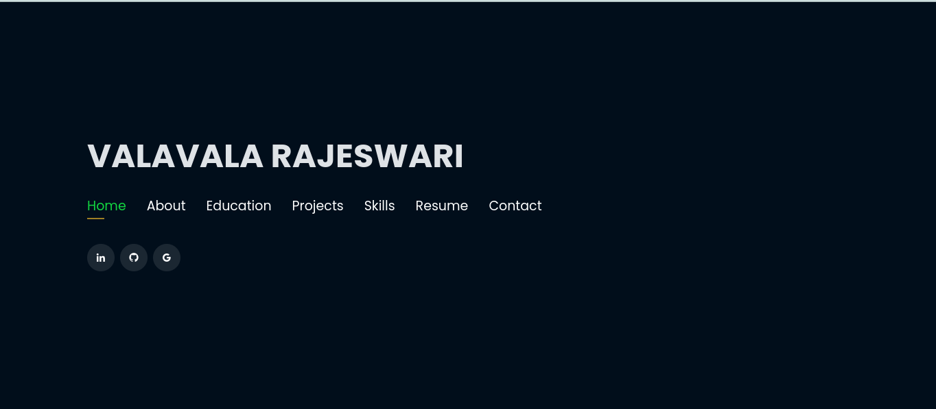

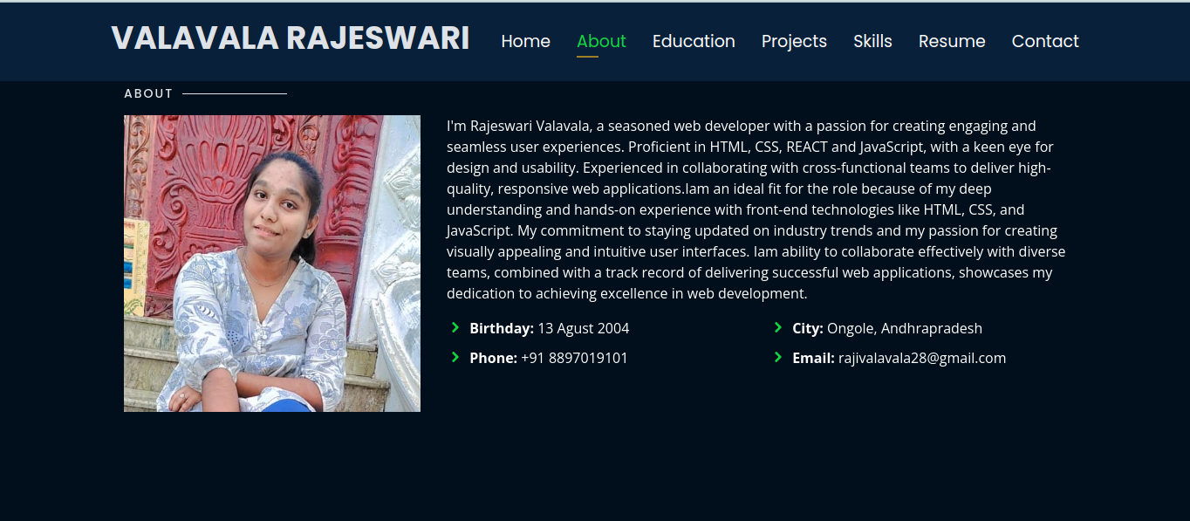

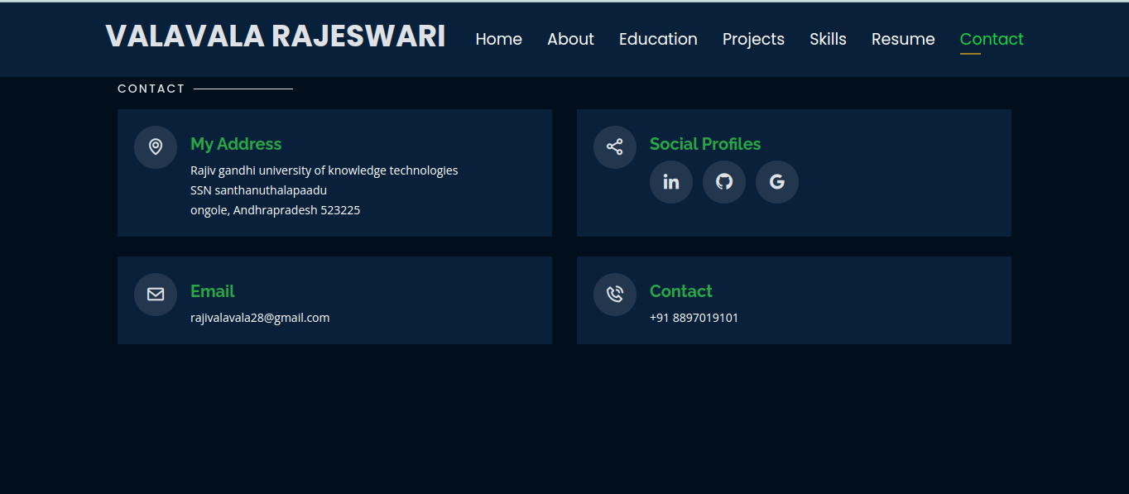

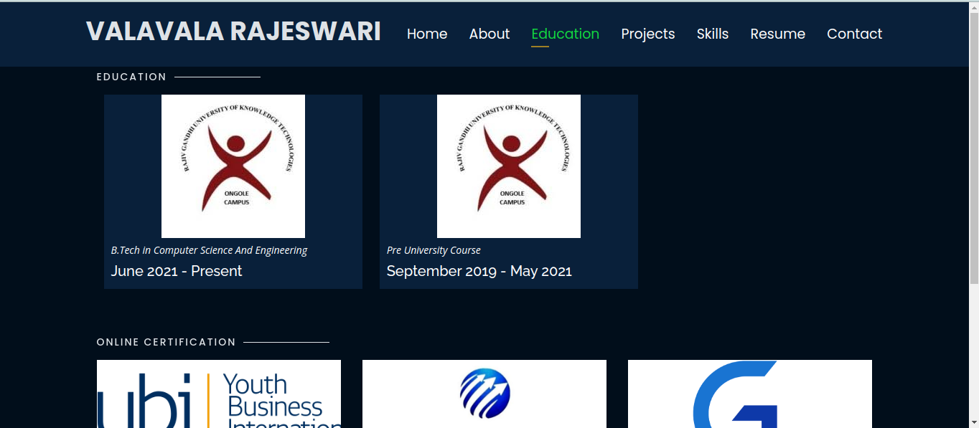

2 E-Commerce Website

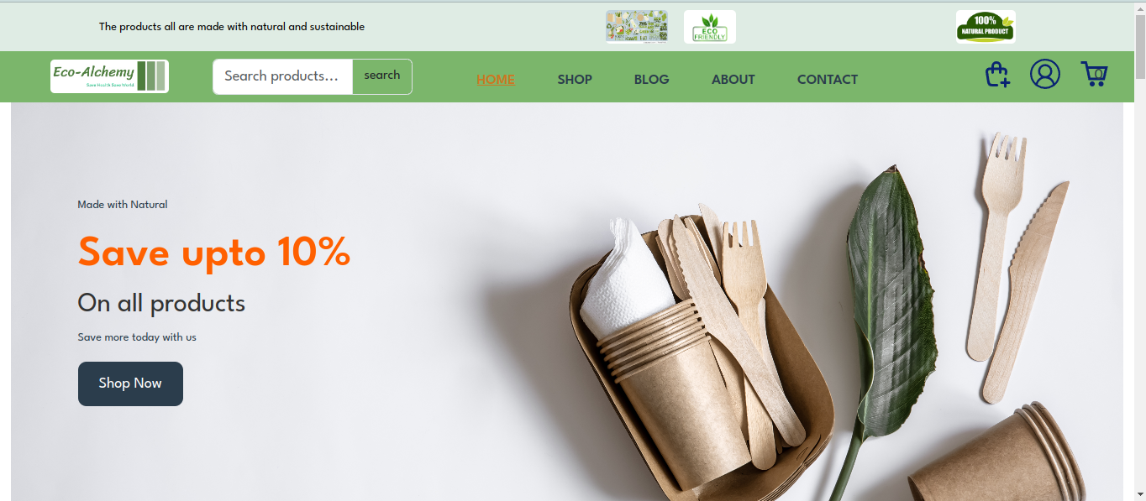

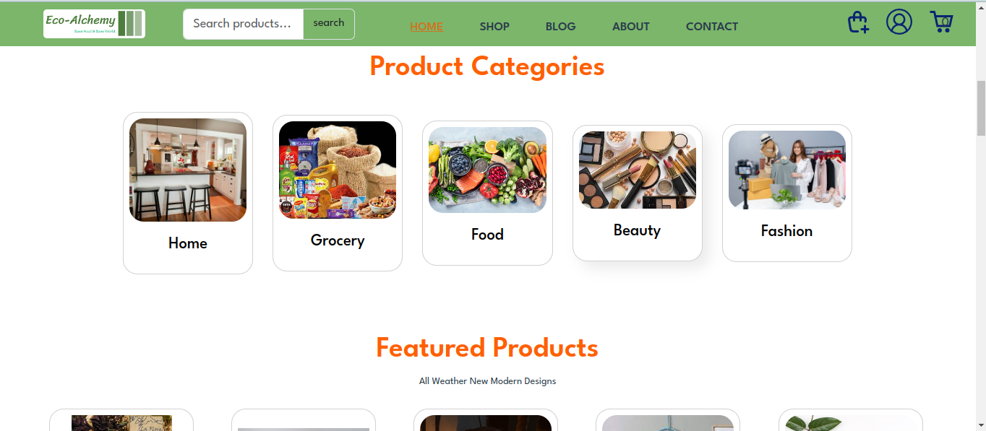
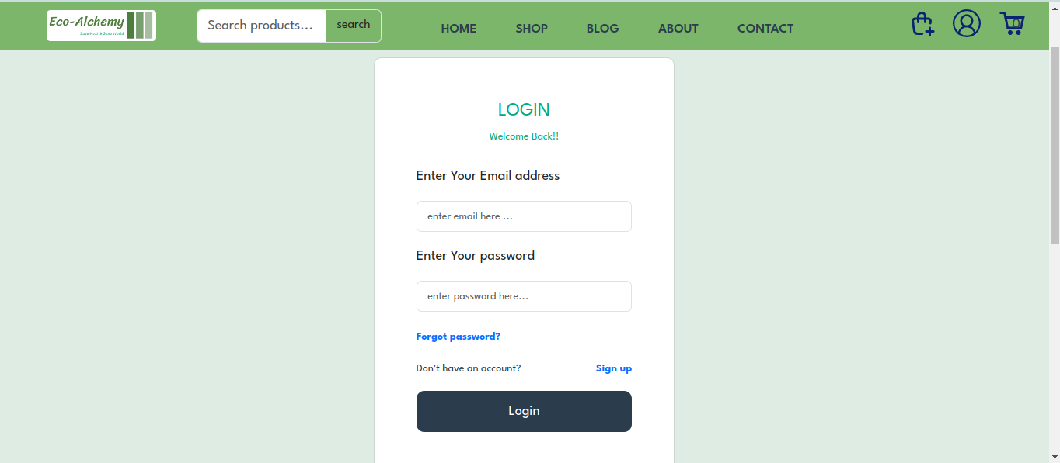

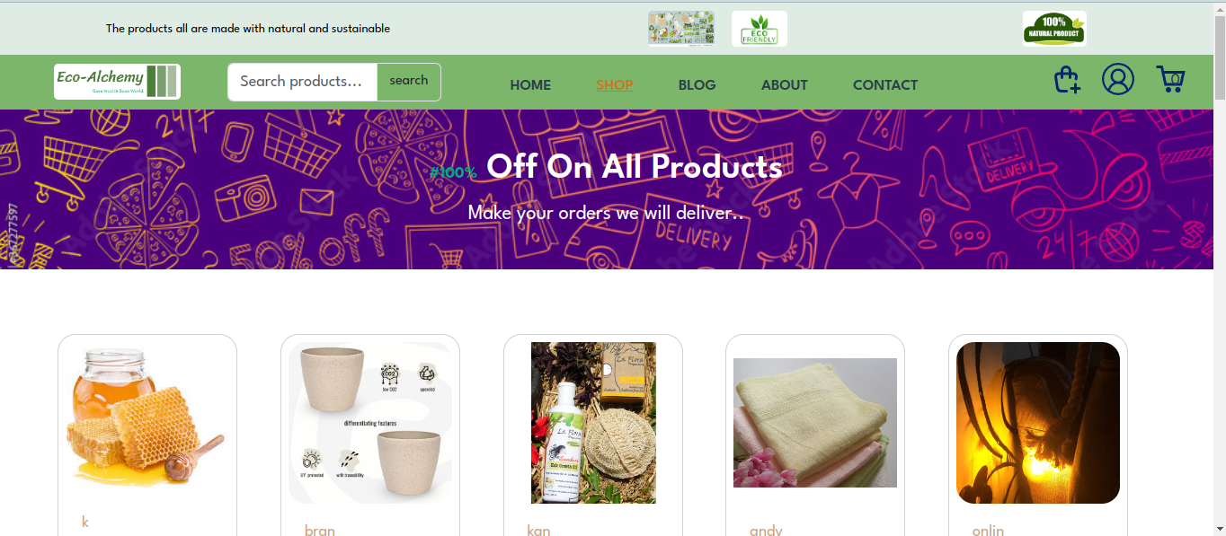

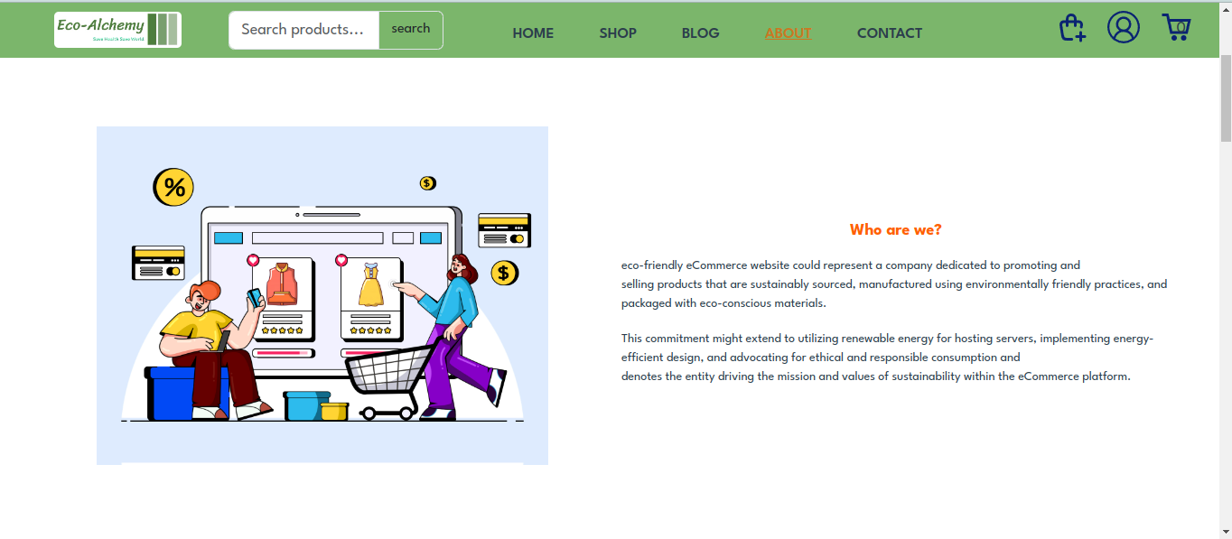

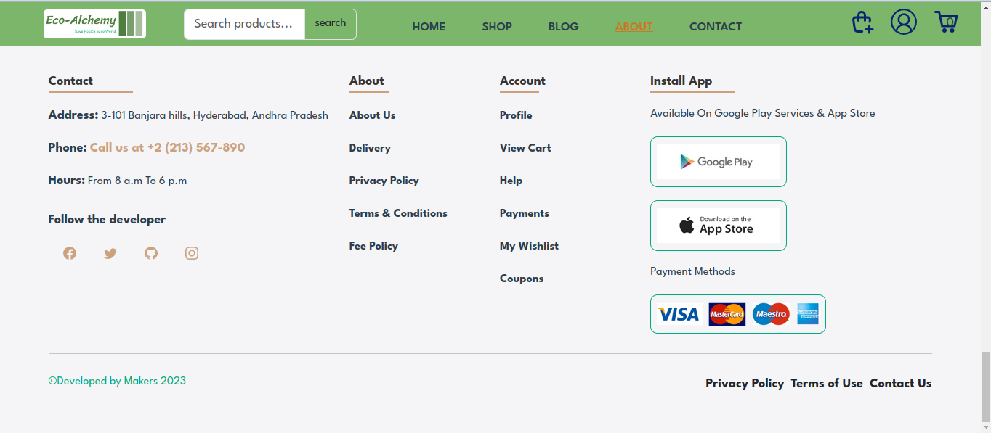

3.E-Learning Website

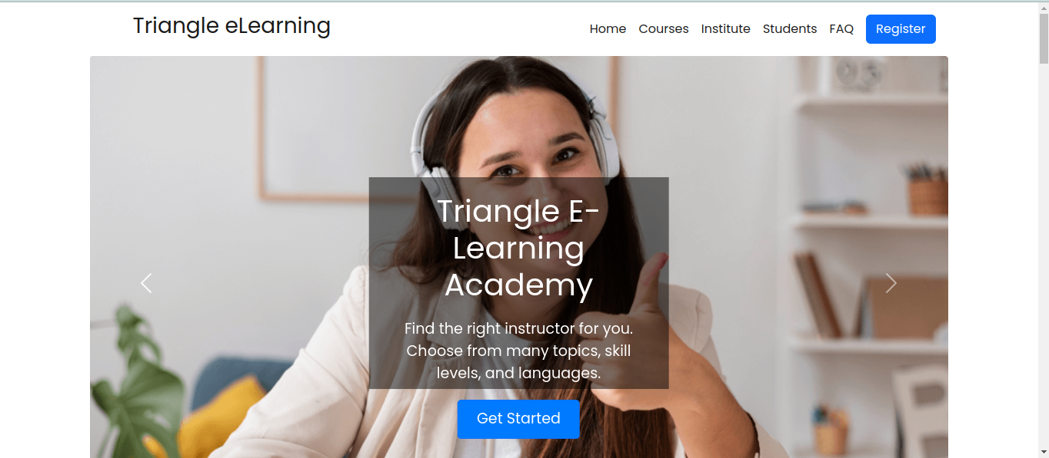

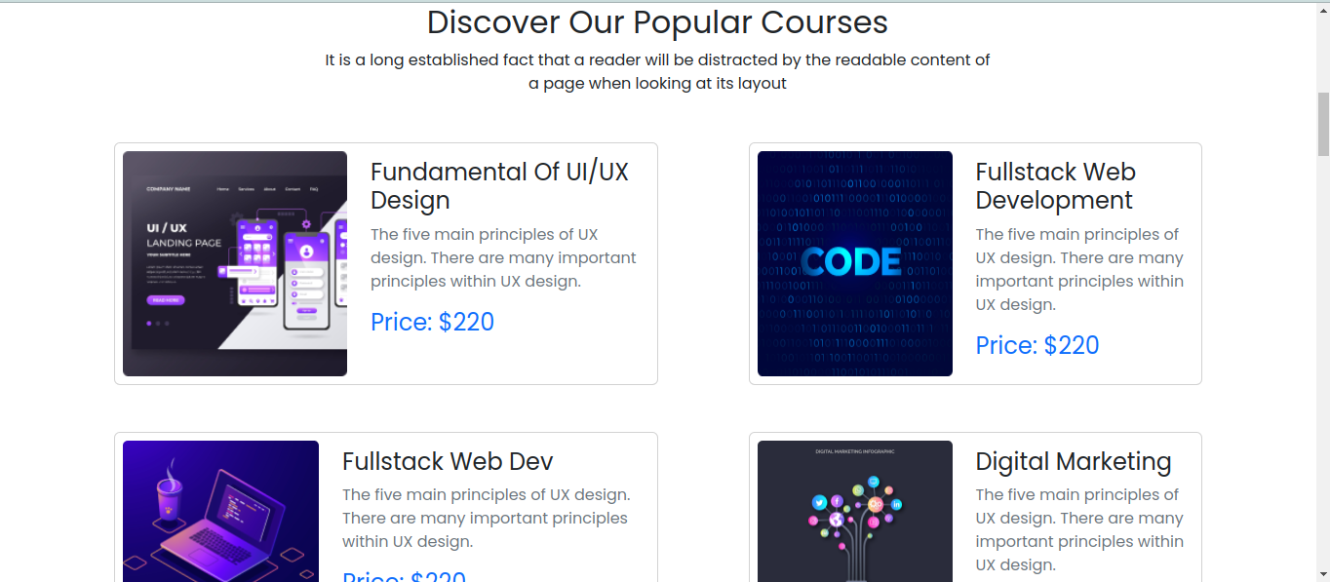



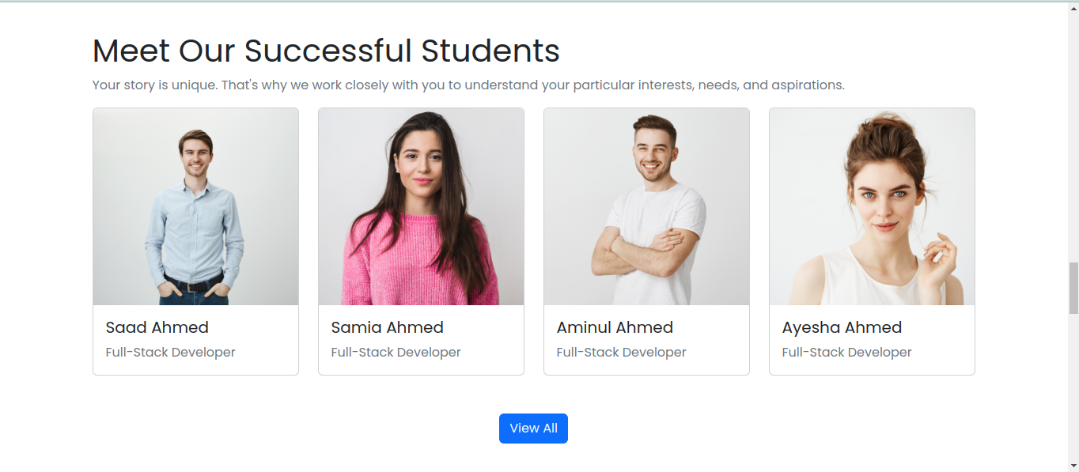

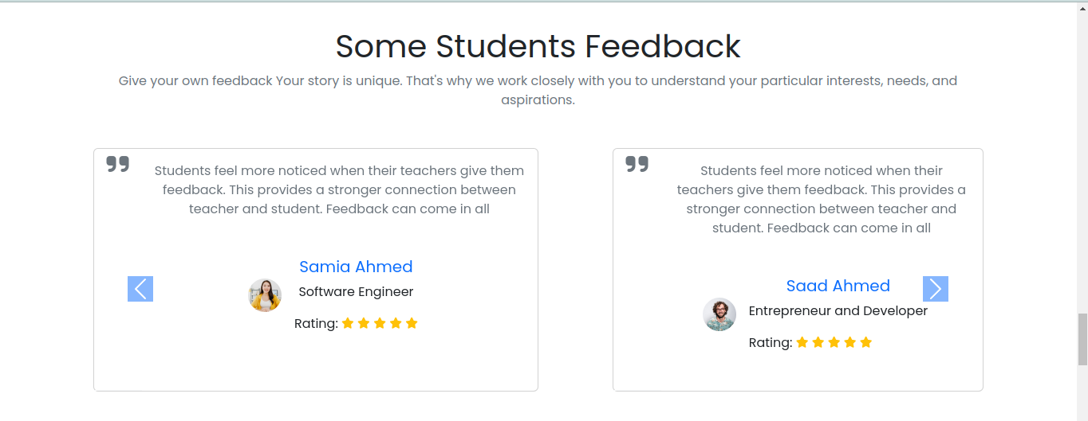

CHAPTER-6
C O NCLUSION

Web development is a dynamic and rapidly evolving field focused on creating the visual and interactive aspects of websites and web applications. At its core, front-end development relies on three fundamental technologies: HTML, CSS, and JavaScript. HTML (HyperText Markup Language) provides the structure of a webpage, defining elements like headings, paragraphs, and links. CSS (Cascading Style Sheets) is responsible for the presentation and layout, enabling developers to style their HTML elements with colors, fonts, and positioning. JavaScript adds interactivity and dynamic behavior, allowing for features like animations, form validations, and asynchronous content updates.

CHAPTER-7 REFERENCES

- https://www.google.com

- https://fonts.googleapis.com

- https://www.googlefonts.com

4 https://chatgpt.com/

